Community Empowerment

Invitation “WarkaWater Towers”
Application to Finance Regional WarkaWater Production Sites and Water Tower Installations
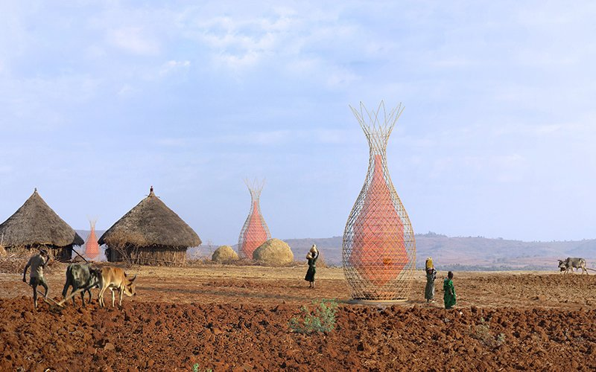

Thalwil, Summer 2016
Martin Klöti
ENGAGE Community Empowerment
Kirchbodenstrasse 60
8800 Thalwil
www.en-gage.ch
martin.kloeti@en-gage.ch, +41 79 405 69 33

Starting Point, Motivation

Water is a critical resource. In governmental meetings in Niger and Nigeria our organisation ENGAGE Community Empowerment got the confirmation, that women and girls spend long precious hours walking long distances in order to collect water. If they could safe this time and for instance spend it at school, they could prepare for a better life.
It is obvious what critical importance water has for life. Not having access to sufficient water creates stress, hassle and war. Safe and clean water is the central key to sufficient nutrition, good health, prosperity for individuals and communities.
The Warka Water Organisation (http://www.warkawater.org) contributes the innovation of the Warka Water Tower, a simple water collection principle invented and designed by its founder Arturo Vittori. It is a tower, where the rigid outer housing is comprised of lightweight and elastic juncus stalks, woven in a pattern that offers stability in the face of strong wind gusts while still allowing air to flow through. A mesh net made of nylon or polypropylene, which calls to mind a large Chinese lantern, hangs inside, collecting droplets of dew that form along the surface. As cold air condenses, the droplets roll down into a container at the bottom of the tower. The water in the container then passes through a tube that functions as a faucet, carrying the water to those waiting on the ground. (Source: http://www.smithsonianmag.com/innovation/this-tower-pulls-drinking-water-out-of-thin-air-180950399/#j6J7JT9MXLt2Z8MV.99)
Up to now Warka Water organisation has collected capital to finance its activities through crowd funding. According to their website, two calls brought around EUR 50’000 each. This is remarkable but compared to the big need and demand of daily water in the arid areas it means far too little power to create sustainable solutions in time.
Our organisation ENGAGE Community Empowerment (www.en-gage.ch) would like to partner with Warka Water (www.warkawater.org) and investing parties in order the realize the following business model and to concretize and use promising synergies.

Business Modell

These are the corner stones of the business idea presented in picture 1:
- Coached and gradually managed by ENGAGE Community Empowerment and local leaders, the regions shall invest in the production and installation of regional workshops that produce Warka Water Towers
- These production workshops sell the water towers to communities and instruct the communities how to use the towers.
- The communities shall get micro credits from investing parties enabling them to pay for the water towers.
- The water harvested from the water towers allow the farmers to incinerate farm land (i.e. through swales), to feed their life stock and to sell the products from gardening and farming on the local markets.
- The farmers pay a percentage of the earnings into a community fund (run by ENGAGE and local trusted partners).
- This community fund pays the credit plus interests back to the investing parties on a regular basis.
In addition as a very useful side effect:
Use the saved time (that was necessarily spent before mainly by women and girls to collect water), to go to school and get education, skills and capabilities to prepare for further paid work, income and future prosperity.
- On a middle and longer term earn a salary in additional industries
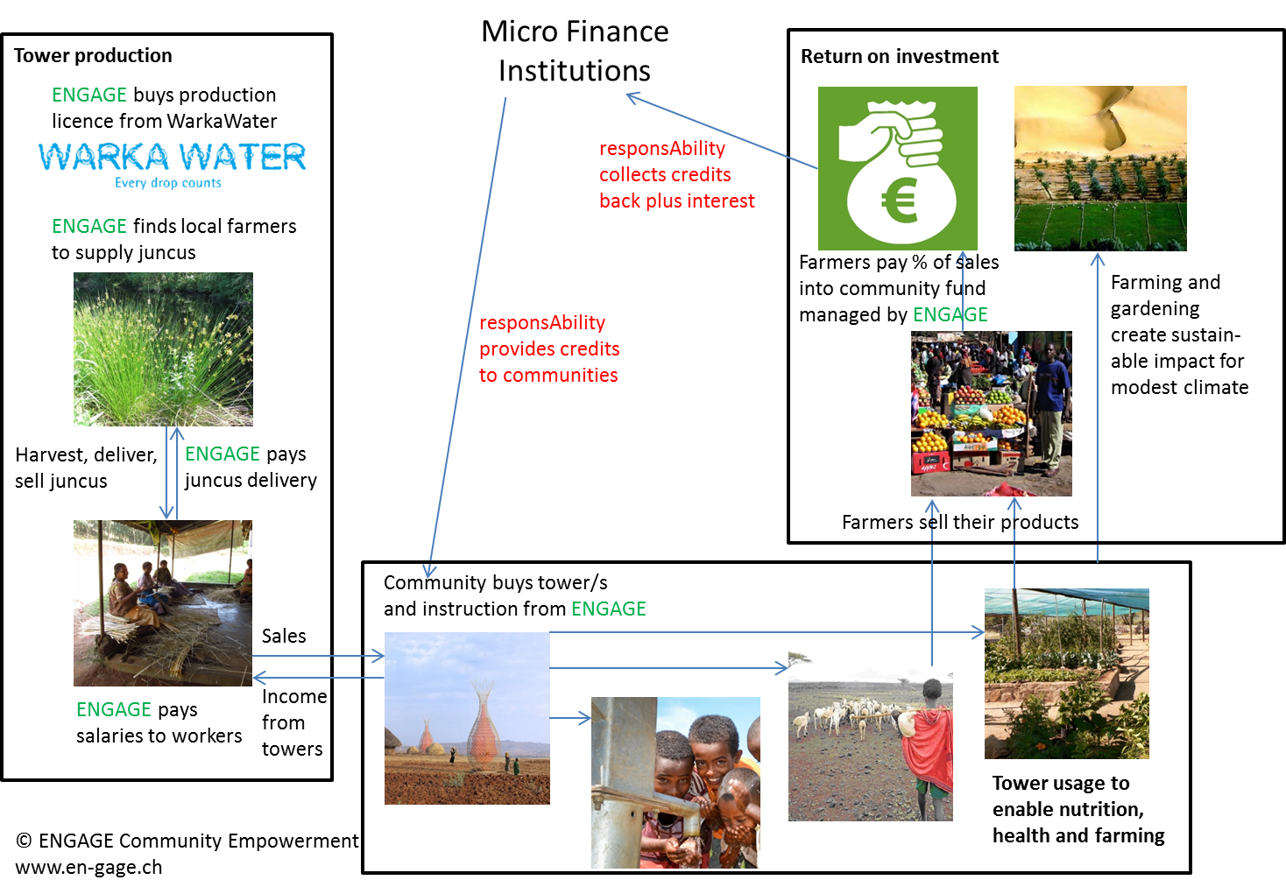

Financial Approach

We are very interested to prepare a detailed calculation by enjoying your expertise and standard figures.
From our side and understanding, the following are very thin indications to set up a calculation:
For the time being, the price of a Warka Tower is indicated at a level of about EUR 500. This is nothing else than a rough indication. The actual prices will be based on the regional conditions for the regional production.
However, ENGAGE would like to establish a licencing agreement with Warka Tower for the allowance to run own regional production sites. Warka Tower has not been contacted yet with this proposal.
ENGAGE would need to ask you or based on the agreements with you to ask additional partners to help to finance the ENGAGE efforts: travel, accommodation, production sites and upfront payments to start production and business.
ENGAGE intends to pay prices and salaries, which allow the workers and the suppliers to sustain their life.
ENGAGE is eager to learn your terms and conditions for micro credits, which are meant to be given to the communities and tune the financial aspects of the business model accordingly.
Thank you for your kind attention.

ENGAGE Community Empowerment
Martin Klöti

